|  |
| --- |
| Ryan McAdie |

R.A.D Technologies Greenhouse Monitoring System

Status

/1 Hardware present?

/1 Title Page

/1 Declaration of Joint Authorship

/1 Proposal (500 words)

/1 Executive Summary

# Declaration of Joint Authorship

We, Ryan McAdie, Daniel Bujold, and Aiden Bolos, confirm that this work submitted is the joint work of our group and is expressed our own words. Any uses made within it of the works of any other author, in any form (ideas, equations, figures, texts, tables, programs), are properly acknowledged at the point of use. A list of the references used is included. The work breakdown is as follows: Each of us provided functioning, documented hardware for a sensor or effector. Ryan McAdie provided documentation for the BME680 Gas and Air Quality Sensor. Daniel Bujold provided documentation for the Capacitive Moisture Sensor. Aiden Bolos provided documentation for the DS18B20 Temperature Sensor. In the integration effort Ryan McAdie is the lead for further development of our mobile application, Daniel Bujold is the lead for the Hardware, and Aiden Bolos is the lead for connecting the two via the Database.

# Proposal

We have created a mobile application, worked with databases, completed a software engineering course, and prototyped a small embedded system with a custom PCB as well as an enclosure (3D printed/laser cut). Our Internet of Things (loT) capstone project uses a distributed computing model of a smart phone application, a database accessible via the internet, an enterprise wireless (capable of storing certificates) connected embedded system prototype with a custom PCB as well as an enclosure (3D printed/laser cut), and are documented via this technical report targeting OACETT certification guidelines.

Intended project key component descriptions and part numbers

Development platform: Raspberry Pi (Broadcom Development Platform)

Sensor/Effector 1: BME680

Sensor/Effector 2: Capacitive Moisture Sensor EK1940

Sensor/Effector 3: DS18820 Temperature Sensor

We will continue to develop skills to configure operating systems, networks, and embedded systems using these key components to complete a small-scale system of a greenhouse monitoring system that will be capable of accurately retrieving and displaying real time up to date vital information for the greenhouse environment. Systems like this currently exist in the world today, however looking at Humber's current system we noticed that all changes can only be made from a central computer located in the greenhouse, we would like to incorporate a remote monitoring and allow remote changes to our system for convenience and to always know how the greenhouse is doing. We also plan to incorporate systems that can be accessed remotely from inside the greenhouse using our related mobile application. Such systems we currently have in mind are; an irrigation system that can automatically or manually water the plants as needed, a ventilation system that can be accessed to regulate temperatures inside the greenhouse and a blind system that can be used to block intense light and heat from the sun if needed for the plants.

Our project description/specifications will be reviewed by, Valeria an employee of the Humber Greenhouse, ideally an employer in a position to potentially hire once we graduate. They will also ideally attend the ICT Capstone Expo to see the outcome and be eligible to apply for NSERC funded extension projects. This typically means that they are from a Canadian company that has been revenue generating for a minimum of two years and have a minimum of two full time employees.

The small physical prototypes that we build are to be small and safe enough to be brought to class every week as well as be worked on at home. In alignment with the space below the tray in the Humber North Campus Electronics Parts kit the overall project maximum dimensions are 12 13/16" x 6" x 2 7/8" = 32.5cm x 15.25cm x 7.25cm.

Keeping safety and Z462 in mind, the highest AC voltage that will be used is 16Vrms from a wall adapter from which+/- 15V or as high as 45 VDC can be obtained. Maximum power consumption will not exceed 20 Watts. We are working with prototypes and that prototypes are not to be left powered unattended despite the connectivity that we develop.

# Executive Summary

With our greenhouse system users will be able to monitor real time vital information to their greenhouses such as temperature, humidity and soil moisture. These values will be updated in real time so users will always know the state of the greenhouse and if changes need to be made. We are also going to implement a remote management system for certain features of the greenhouse such as an irrigation/feeding system, ventilation and fan system and a light blocking or blind system. With all these, a user would be able to take manual control of the greenhouse and make remote changes to the system that could potentially be better for the plants then just using the automated system. Our system will be one of the first of its kind to implement all the necessary features of a greenhouse monitoring system as well as go above and beyond to achieve features and requirements that would make managing a greenhouse a little more easier with more peace of mind knowing that your plants are always in your hands.

Contents

Declaration of Joint Authorship 3

Proposal 5

Executive Summary 7

List of Figures 11

1.0 Introduction 13

1.1 Scope and Requirements 13

2.0 Background 19

3.0 Methodology 21

3.1 Required Resources 21

3.1.1 Parts, Components, Materials 21

3.1.2 Manufacturing 21

3.1.3 Tools and Facilities 21

3.1.4 Shipping, duty, taxes 21

3.1.5 Time expenditure 21

3.2 Development Platform 21

3.2.1 Mobile Application 21

3.2.2 Image/firmware 23

3.2.3 Breadboard/Independent PCBs 23

3.2.4 Printed Circuit Board 25

3.2.5 Enclosure 26

3.3 Integration 27

3.3.1 Enterprise Wireless Connectivity 28

3.3.2 Database Configuration 28

3.3.3 Security 28

3.3.4 Testing 28

4.0 Results and Discussions 29

5.0 Conclusions 31

6.0 References 33

7.0 Appendix 35

7.1 Firmware code 35

7.2 Application code 35

# List of Figures

Figure 1. By Android Studio - https://developer.android.com/studio/, CC BY-SA 4.0, https://commons.wikimedia.org/w/index.php?curid=74094999 22

Figure 2. Initial schematic. This work is a derivative of "http://fritzing.org/parts/" by Fritzing, used under CC:BY-SA 3.0. 24

Figure 3. This work is a derivative of "http://fritzing.org/parts/" by Fritzing, used under CC:BY-SA 3.0. 24

Figure 4. Breadboard prototype. 25

Figure 5. PCB design This work is a derivative of "http://fritzing.org/parts/" by Fritzing, used under CC:BY-SA 3.0. 26

Figure 6. Humber Sense Hat Prototype PCB. 26

Figure 7. Example enclosure. 27

# Introduction

With our project we aim to construct and develop a greenhouse monitoring system. Systems like this are already available to consumers and industry professionals yet most lack certain features that many people would like to see incorporated. With our project we aim to achieve a device that has all the features and specifications to benefit everyone. Users will also be able to have up to date information for key variables inside of a greenhouse environment. Some of these key values that will be interpreted; current temperature, current humidity, gas and air quality, and soil moisture levels. These values will then be added to a database hosted by Amazons’ Firestore, which we will then pick up inside of an Android mobile application that we are currently developing, were users will be able to view and interact with the greenhouse in real time. Things like watering the plants, opening vents, turning on fans, and lowering curtains will be some of the features that we also plan to incorporate into the finished project to allow remote management for the greenhouse. According to our project schedule, we have currently completed the first half of our project requirements by successfully completing our previous semester which has allowed us to move on to our current semester where we will continue working and later finish up with our project. This project is in collaboration with the Humber Arboretum, who is in need of an updated system to better closely monitor the environment and habitat of their plants.

## 1.1 Scope and Requirements

We are creating an Internet of Things (IoT) capstone project that uses a distributed computing model and is documented by an OACETT certification acceptable technical report. This project will consist of a Broadcom (Raspberry Pi 4) development platform with a custom PCB for connecting sensors, which will be encased in a custom enclosure. The Broadcom development platform will connect to the internet through enterprise wireless (capable of storing certificates). This device will be responsible for picking up/processing readings from the sensors and storing them within a database. The device will be capable of reading temperature from the DS18B20, air quality/humidity from the BME680, and soil moisture from the EK1940. The maximum dimensions for this project are 12 13/16" x 6" x 2 7/8" = 32.5cm x 15.25cm x 7.25cm. We will be adhering to CSA Z462, the highest AC voltage that will be used is 16Vrms from a wall adapter from which +/- 15V or as high as 45 VDC can be obtained. Maximum power consumption will not exceed 20 Watts.

This database will be hosted through Google’s Firebase and will be used to store the temperature, air quality/humidity, and soil moisture readings. These stored readings will be accessible for retrieval and display. It will also store login credentials of employees using the mobile application.

The mobile application will be an Android application designed for phones running Marshmallow 6.0 or higher. It will consist of a login screen for greenhouse employee authentication, and a guest login for all others. The application will be able to retrieve/display sensor data in real time, as well as have a refresh button to update readings. It will also have a weather widget displaying the outside weather local to the greenhouse. This application will be programmed in Java using Android Studio.

This project will be able to auto-maintain greenhouse conditions by comparing sensor readings to given parameters, and using built-in algorithms to determine which parts of the environment need adjusted.

This project will not measure certain readings such as sunlight and plant nutrient level. It will not feature its own outdoor weather station, but as stated above, it will rely on local weather data. This device is a prototype and therefore is not CSA approved.

Raspberry Pi 4

- CPU – Broadcom BCM2711, Quad core Cortex-A72 64-bit SoC @ 1.5GHz

- RAM – 4GB LPDDR4-2400 SDRAM

- WiFI – 2.4 GHz and 5.0 GHz IEEE 802.11ac wireless, Bluetooth 5.0, BLE

- Ethernet – Gigabit

- USB – 2 USB 3.0 ports; 2 USB 2.0 ports

- GPIO header – Raspberry Pi standard 40 pin

- HDMI – 2 × micro-HDMI ports

- Storage – Micro-SD card slot for loading operating system and data storage

- OS – Raspbian Buster (Debian Linux based)

DS18B20

- Measures Temperatures from -55°C to +125°C (-67°F to +257°F)

- ±0.5°C Accuracy from -10°C to +85°C

- Programmable Resolution from 9 Bits to 12 Bits

BME 680

- Interface I²C and SPI

- Pressure: 300 - 1100 hPa

- Humidity: 0 - 100%

- Temperature: -40 - 85°C

EK1940

- Interface PH2.54-3P

- Capacitive sensor

- Analog out

Custom PCB

- 2 layers

- 1.6mm thick

- lead-free soldering

- 1oz copper weight

- FR4 standard

- 16 mil min. trace spacing

Custom Enclosure

- 3D printed using PLA filament

- laser cut 3mm acrylic

Database

- Firebase Cloud Firestore

- NoSQL cloud based

- flexible, hierarchical data storage (documents and collections)

- persists data on device for offline use

Mobile Application

- native Android application

- minimum Marshmallow 6.0 (API 23) or higher

- phones and tablets (portrait mode)

- secure login for staff

Report

/1 Hardware present?

/1 Introduction (500 words)

/1 Scope and Requirements

/1 Background (500 words)

/1 References

# 2.0 Background

The real-life problem being solved by this project is Humber’s arboretum (Humber Arboretum, 2020) and several other nurseries lack a proper system to measure temperature, humidity, and soil moisture levels. This monitoring system will help them keep track of everything related to the health of the habitat inside the greenhouse. The device is capable of reading temperature, humidity and soil moisture to be used in plant nurseries. Along with a constructed smartphone mobile application that can be used to access a database to show users real-time information regarding temperature, humidity and soil moisture. The device is focused on solving these particular problems, will automate the greenhouse maintenance operations and monitor the growth conditions inside the greenhouse closely. (Humber Arboretum, 2020)

Humber Arboretum has a system currently installed by a company called Argus Controls (Argus Controls, 2020). The system consists of sensors/effectors, control panels, power panels, and connects to Argus servers. It can then be accessed/controlled locally from the client PC or remotely by Argus. Sensors monitor temperature, humidity, soil moisture, gas levels (CO and CO2), and a weather station monitors light, temperature, wind, rain, and snow outdoors. Effectors include air vents/fans, a mister, roof shades/curtains, evaporative cooling/heating pipes, and an irrigation system (not enabled). The system monitors all the sensors and uses the effectors to control the environment in the greenhouse. Most effectors rely on the readings of multiple sensors (i.e. curtains rely on light, temperature, and humidity). Argus mostly manages the system remotely. The system is lacking a functional irrigation system, nutrient/seeding system, different zones for different types of plants, and adjustable shade/lighting for certain plants.

Our device includes 3 sensors, a PCB board and a CPU (Raspberry Pi, 2020) that will connect to the app through Bluetooth and with multiple sensors connected to the greenhouse, we will be able to monitor all internal and external data and make any changes to the growing environment in the greenhouse in real-time. All of this data using firebase will be collected and mapped so we can control the outcome of a particular instance in the greenhouse. An example would be triggering irrigation when the solar level reaches a certain value and many more. With this type of flexibility, any greenhouse related data could be collected and controlled via automation. The greenhouse staff will be able to read and interact with that data directly through any secure Internet network and connecting their android smartphone through Bluetooth allowing them to view their greenhouse information with any android smartphone and have the capabilities needed to maintain and manually control the environment inside the greenhouse closely.

This proposal presents a plan for providing a solution for the arboretum at Humber College. This is an opportunity to combine the skills and knowledge that we’ve learned throughout our program and create a capstone project demonstrating our ability to create a greenhouse system that will improve the current system and provide the staff at Humber’s arboretum an easier more efficient solution to maintain the greenhouse from anywhere.

# Methodology

We are building our project based on our college course outlined to demonstrate our knowledge and understanding in key engineering concepts. We plan on solving the issues with current greenhouse monitoring systems that do not allow them to be very mobile in the sense that most actions must be given locally at the greenhouse typically at PC or control center located on site. With this we plan to incorporate a secure mobile application capable of reading key values in the habitat as well as being able to make remote changes to the environment as a user sees fit.

## 3.1 Required Resources

In this portion of the document we will be discussing the parts/components/materials we will be using, how we plan on building a custom PCB to incorporate all of our sensors and components as well as a case to house all the electronics, we will go over the tools and facilities we plan to utilize to complete our project, our plan to maximize efficiency and reduce cost in terms of shipping, duty and taxes on our items and lastly, we will discuss our working time over our lead time.

Report

/1 Parts/components/materials (500 words)

/1 PCB, case (500 words)

/1 Tools, facilities (500 words)

/1 Shipping, duty, taxes (250 words)

/1 Working time versus lead time (250 words)

### 3.1.1 Parts, Components, Materials

### 3.1.2 Manufacturing

### 3.1.3 Tools and Facilities

We plan to use the most out of the resources given to us at Humber College, which will allow us to complete our project in a timely manner. Being students at Humber College we are given access to state of the art facilities and tools to help us advance our project as well as our knowledge and understanding for topics related to computer engineering technology. Tools such as soldering irons, de-soldering irons and a fume ventilation system will allow us to solder our own custom designed PCB that will incorporate all of our sensors and effectors. Other tools we will take advantage off at the college are the lab equipment such as power supplies and digital multi-meters to read accurate values for voltage and resistance when it comes to making our PCB. We are also able to send PCB files to the colleges’ prototype lab to have them make the custom PCB for us. The advantage to using the college for the printing of our PCB gives us the chance to resend new and updated files for new and revised boards if we feel like we need to make changes or if the pervious board didn’t work according to plan. This also gives us the relief that if we were to make a mistake will soldering we can have another board printed to start fresh. By using a business outside the college we would have to be sure that our design is what we wanted or that we weren’t going to make a mistake because that would lead to us spending more money for new boards and more time for waiting to receive the boards. The college also offers us the opportunity to use the resources in our prototype lab, things like a laser cutter that we will make use of to cut acrylic for pieces of our custom case. This will allow us to demonstrate our knowledge and understanding with the fundamentals of laser cutting. The prototype lab also allows us access to a 3D printing machine, we will use this machine to fabricate the main components for the custom case. The pieces we create from the laser cutter and 3D printing machine will allow us to fabricate a complete custom case to enclose our development platform, custom PCB and all of our sensors and effectors. Using the college for things like the laser cutter and 3D printing allows us to constantly update or make changes to our case when we need them allowing us to receive the new case within 1-2 days instead of outsourcing to a business outside the school where we would have to spend money and waste time to receive the case which wastes valuable resources in terms to the project. Using the college for most of the main features of the project allows us to operate mostly out of the college by using the resources given to us as students. These are the majority and main tools and facilities we will be using to undertake the preparation and the completion of or project.

### 3.1.4 Shipping, duty, taxes

### 3.1.5 Time expenditure

Working time versus lead time.

## 3.2 Development Platform

### 3.2.1 Mobile Application

Status

/1 Hardware present?

/1 Memo by student A + How did you make your Mobile Application? (500 words)

/1 Login activity

/1 Data visualization activity

/1 Action control activity

Include screenshots such as Figure 1. Testing. Progress.

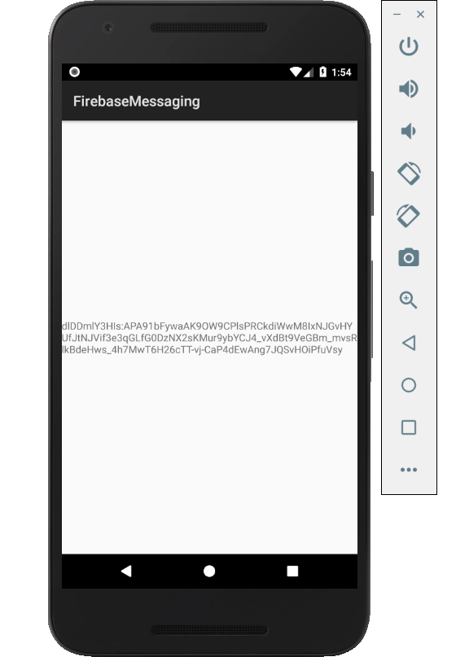

Figure 1. By Android Studio - https://developer.android.com/studio/, CC BY-SA 4.0, https://commons.wikimedia.org/w/index.php?curid=74094999

### 3.2.2 Image/firmware

Status

/1 Hardware present?

/1 Memo by student B + How did you make your Image/firmware? (500 words)

/1 Code can be run via serial or remote desktop

/1 Wireless connectivity

/1 Sensor/effector code on repository

### 3.2.3 Breadboard/Independent PCBs

Status

/1 Hardware present?

/1 Memo by student C + How did you make your hardware? (500 words)

/1 Sensor/effector 1 functional

/1 Sensor/effector 2 functional

/1 Sensor/effector 3 functional

The initial schematic design, Figure 2, based on datasheets (Bosch Sensortec, 2019) led to a breadboard layout Figure 3 that was realized Figure 4.

How did you build your Prototype: Breadboard?

Then a PCB was designed, Figure 5, and populated (Figure 6). Bill of Materials, Case, Time commitment. Testing. Progress.

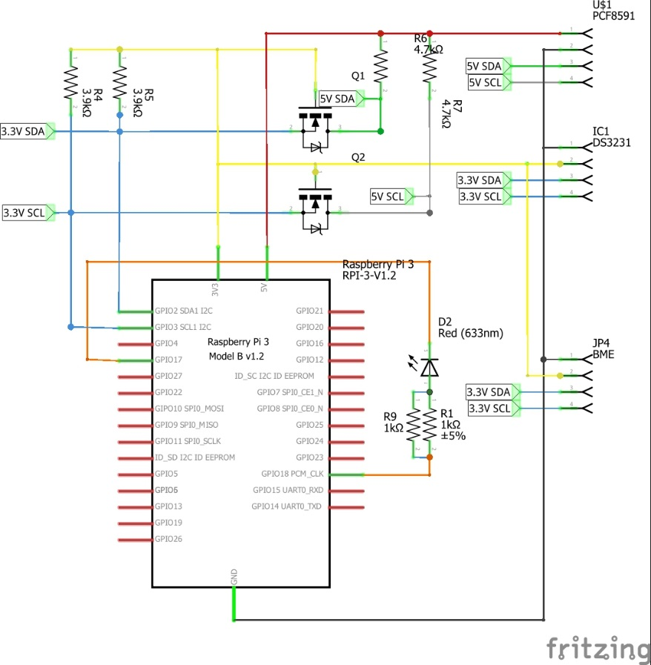

Figure 2. Initial schematic. This work is a derivative of "http://fritzing.org/parts/" by Fritzing, used under CC:BY-SA 3.0.

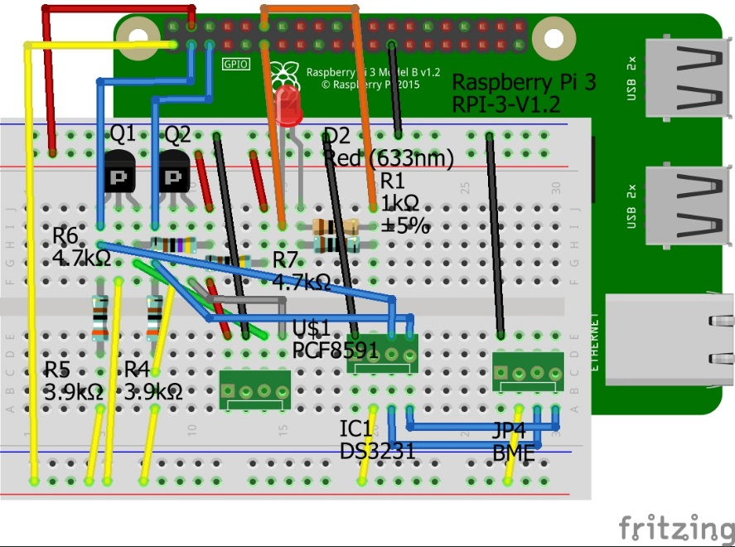

Figure 3. This work is a derivative of "http://fritzing.org/parts/" by Fritzing, used under CC:BY-SA 3.0.

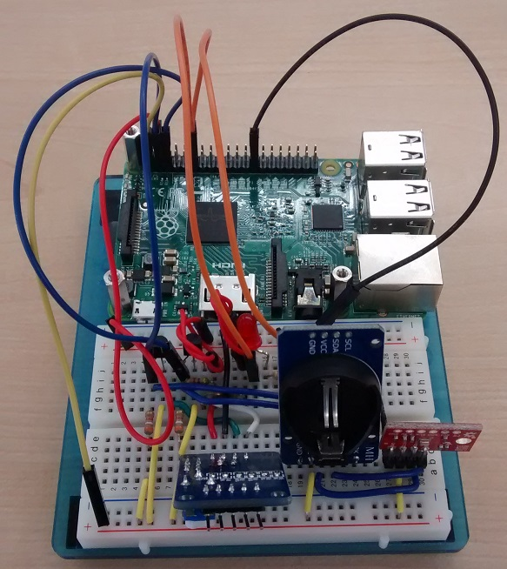

Figure 4. Breadboard prototype.

### 3.2.4 Printed Circuit Board

Demo

/1 Hardware present?

/1 PCB Complete and correct

/1 PCB Soldered wire visible but trim, no holes or vacancies

/1 PCB Tested with multimeter

/1 PCB Powered up

How did you build your Prototype: PCB?

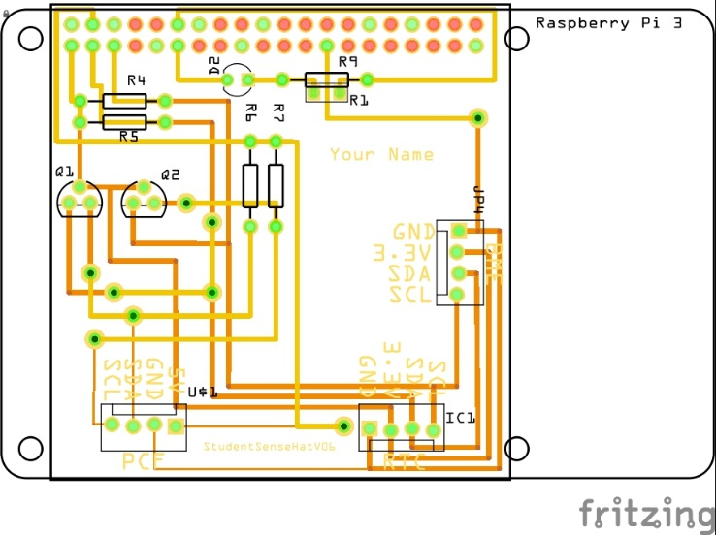

Figure 5. PCB design This work is a derivative of "http://fritzing.org/parts/" by Fritzing, used under CC:BY-SA 3.0.

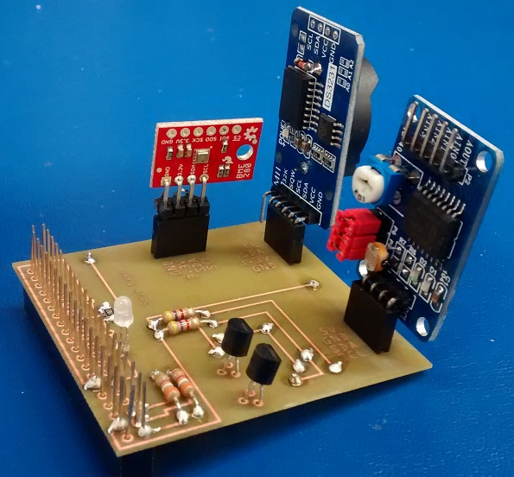

Figure 6. Humber Sense Hat Prototype PCB.

### 3.2.5 Enclosure

Demo

/1 Hardware present?

/1 Case encloses development platform and custom PCB.

/1 Appropriate parts securely attached.

/1 Appropriate parts accessible.

/1 Design file in repository, photo in report.

How did you build your Prototype: Case?

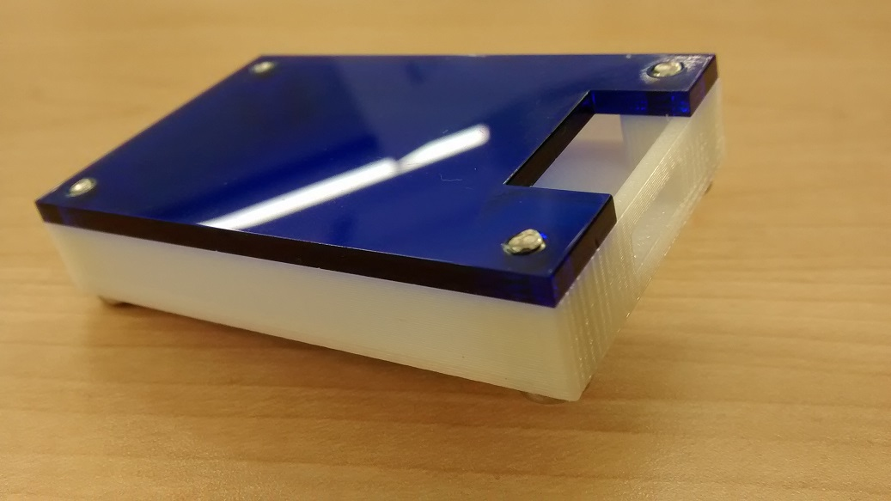

Figure . Example enclosure.

## 3.3 Integration

Demo

/1 Hardware present?

/1 Data sent by hardware

/1 Data retrieved by mobile application

/1 Action initiated by mobile application

/1 Action recieved by hardware

Report

/1 Enterprise wireless connectivity (250)

/1 Database configuration (250 words)

/1 Security considerations (500 words)

/1 Unit testing (900 words)

/1 Production testing (100 words)

### 3.3.1 Enterprise Wireless Connectivity

How did you make a Database accessible by both your Prototype and Mobile Application?

### 3.3.2 Database Configuration

### 3.3.3 Security

### 3.3.4 Testing

Unit testing and Production testing.

# 4.0 Results and Discussions

Is your prototype perfect? What did you learn?

# 5.0 Conclusions

If you were making 1000 of these.

Report

/1 Hardware present?

/1 Checklist truthful

/1 Valid Comments

/1 Results and Discussion (500 words)

/1 Conclusion

# 6.0 References

*Argus Controls*. (2020). Retrieved from Argus is a member of the Conviron Group of Companies : https://www.arguscontrols.com/

Bosch Sensortec. (2019, July). *BME680 - Datasheet.* Retrieved from Robert Bosch GmbH: https://ae-bst.resource.bosch.com/media/_tech/media/datasheets/BST-BME680-DS001.pdf

*Humber Arboretum*. (2020). Retrieved from Humber Arboretum and centre for urban ecology: https://humber.ca/arboretum/

*Raspberry Pi*. (2020). Retrieved from Raspberry Pi 4 Tech Specs: https://www.raspberrypi.org/products/raspberry-pi-4-model-b/specifications/

# 7.0 Appendix

## 7.1 Firmware code

Demo

/1 Hardware present?

/3 Code runs concurrently for all sensors/effectors

/1 Project repository contains integrated code

Status

/1 Memo including updates

/1 Financial update

/1 Progress update

/1 Modified Code Files in Appendix

/1 Link to Complete Code in Repository

## 7.2 Application code

Demo

/1 Hardware present?

/1 Memo by student A

/1 Login activity

/1 Data visualization activity

/1 Action control activity

Report

/1 Login activity

/1 Data visualization activity

/1 Action control activity

/1 Modified Code Files in Appendix

/1 Link to Complete Code in Repository